### ASSIGNMENT 1

**NAME:** SREEMATHI SIVAKUMAR **REGISTRATION NO:** 20BEC1174 **DATE:** 20/05/2023

**ULTRASONIC SENSOR CIRCUIT USING WOKWI**

**Aim:** To construct a circuit with Ultrasonic sensor in WOKWI such that if distance is less than 100 cm, the led must glow.

**Software required:** WOKWI

**Components Required:** ESP32, 100 ohm Resistor, Ultrasonic sensor, LED, Connecting wires

## Circuit Diagram:

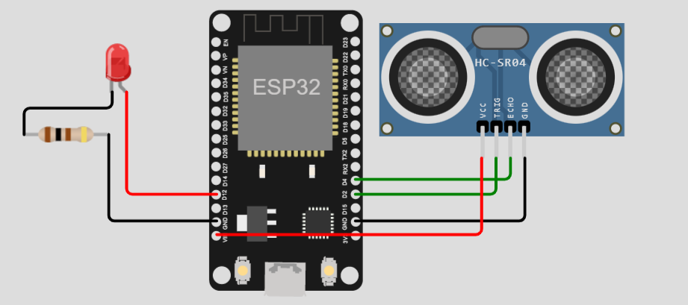

**Simulation:**

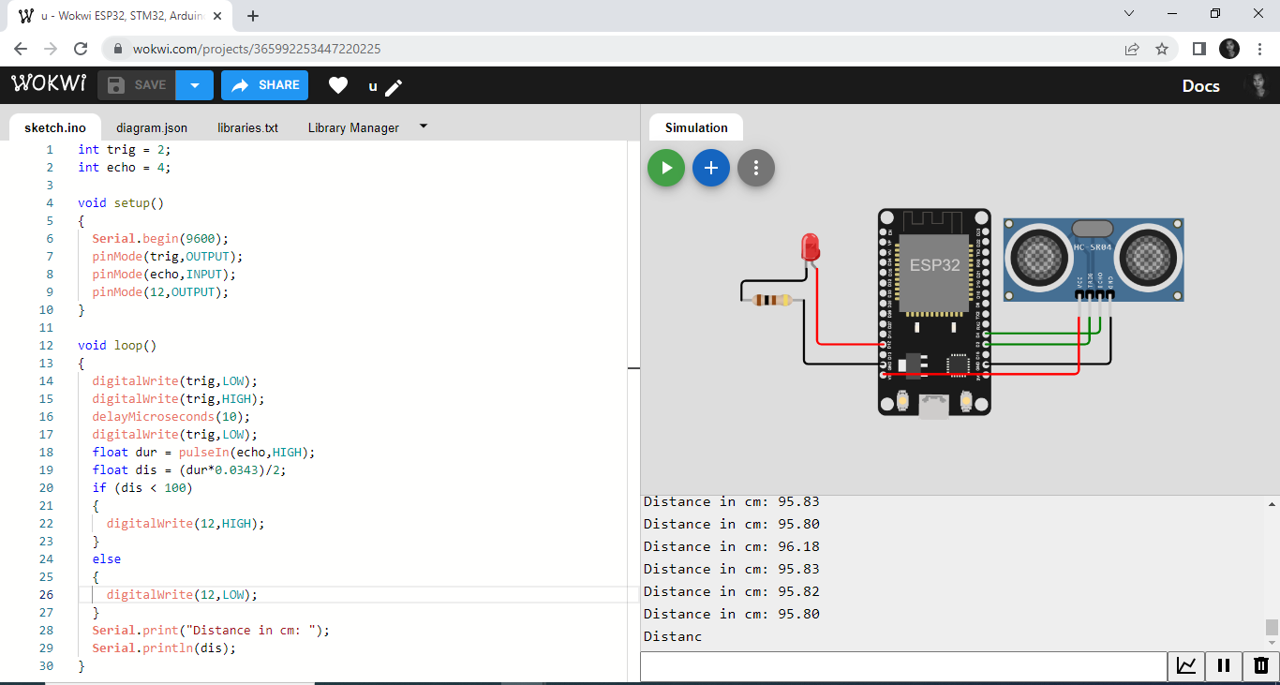**Procedure:**

1. Place the components on the breadboard
2. Connect the Ultrasonic Sensor's TRIG pin to the ESP32's D2 pin.
3. Connect the Ultrasonic Sensor's ECHO pin to the ESP32's D4 pin.
4. Connect the Ultrasonic Sensor's GND pin to the ESP32's GND.1 pin.
5. Connect the LED's Cathode (C) to the Resistor's pin 1.
6. Connect the Resistor's pin 2 to the ESP32's GND.2 pin.
7. Connect the LED's Anode (A) to the ESP32's D12 pin.
8. Connect the Ultrasonic Sensor's VCC pin to the ESP32's VIN pin.
9. Upload the necessary code.
10. Run the simulation.

**Code :**

int trig = 2;

int echo = 4;

void setup()

{

**Serial**.begin(9600);

  pinMode(trig,OUTPUT);

  pinMode(echo,INPUT);

  pinMode(12,OUTPUT);

}

void loop()

{

  digitalWrite(trig,LOW);

  digitalWrite(trig,HIGH);

  delayMicroseconds(10);

  digitalWrite(trig,LOW);

  float dur = pulseIn(echo,HIGH);

  float dis = (dur*0.0343)/2;

  if (dis < 100)

  {

    digitalWrite(12,HIGH);

  }

  else

  {

    digitalWrite(12,LOW);

  }

**Serial**.print("Distance in cm: ");

**Serial**.println(dis);

}

**Outputs :**

**When Distance > 100 cm**

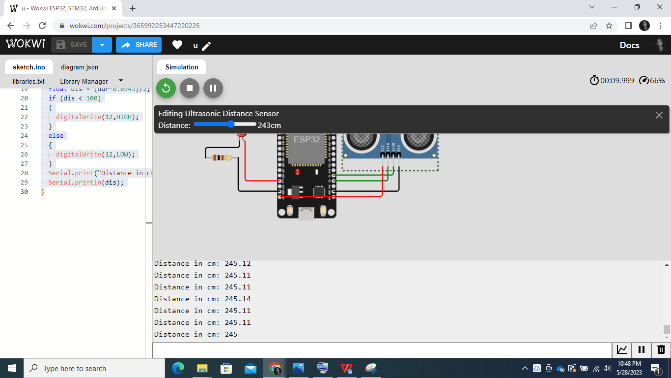

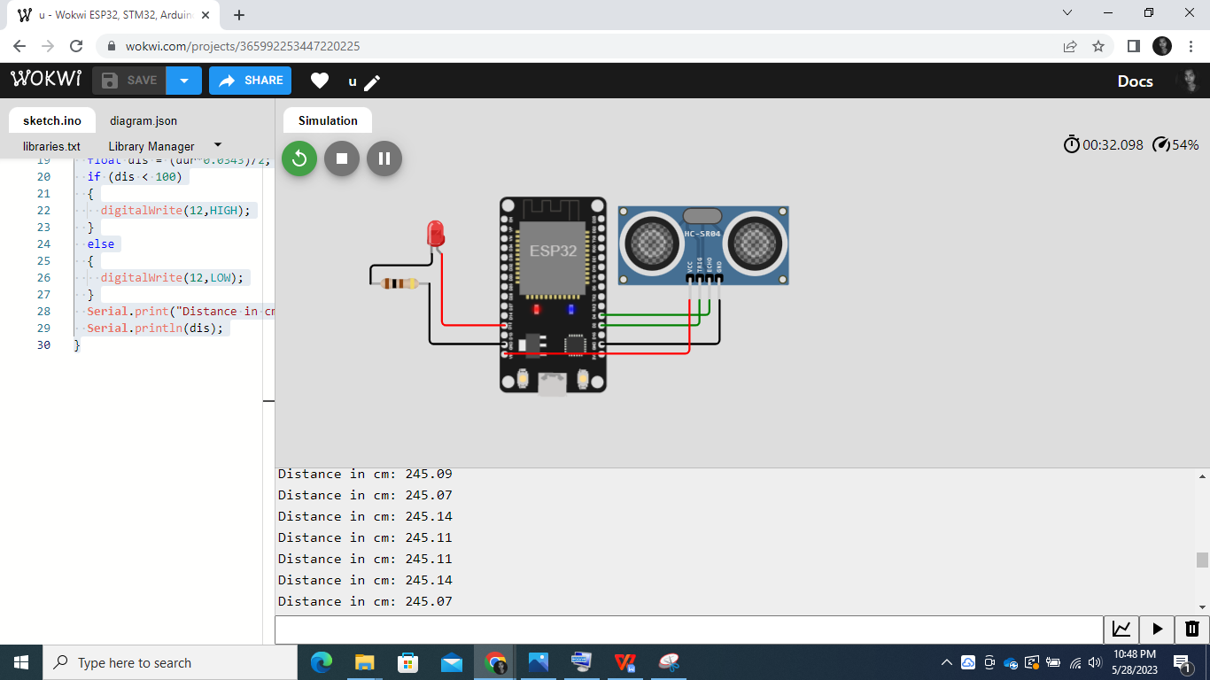

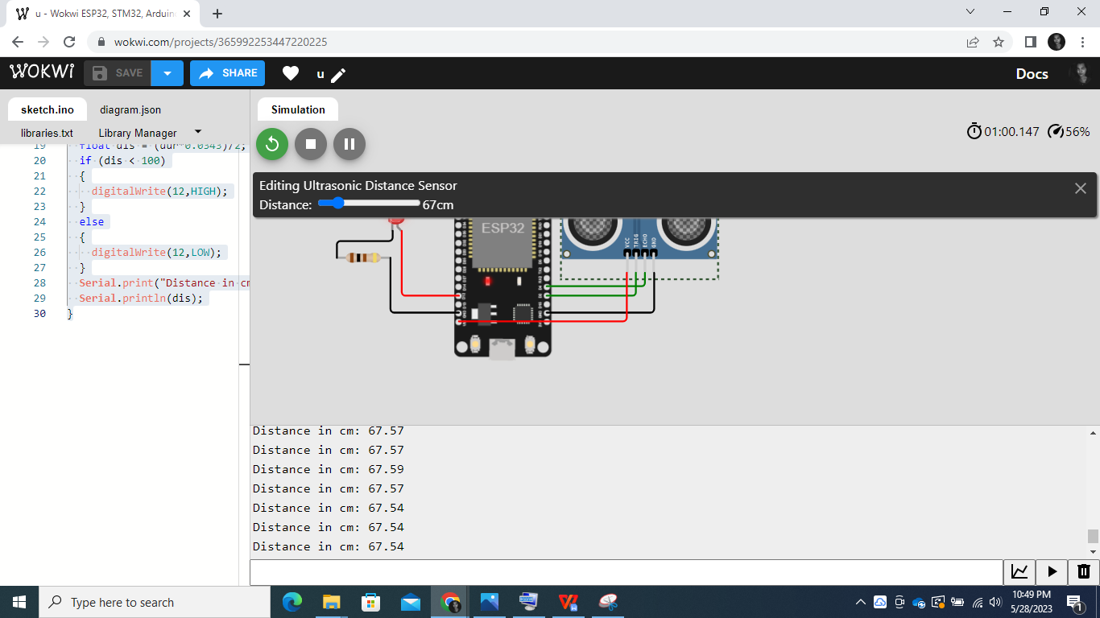**When Distance < 100 cm**

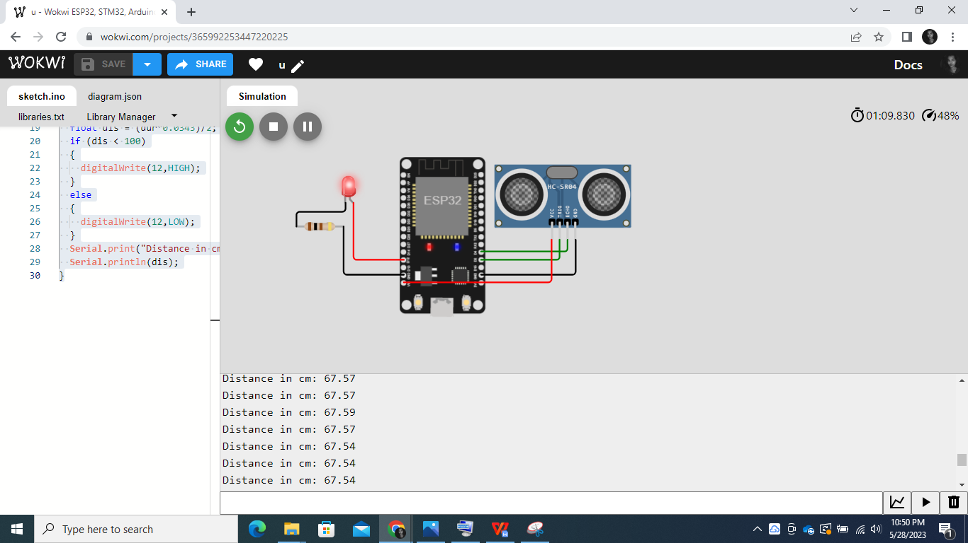

The circuit has been constructed in WOKWI and the LED glows when distance <100 cm

**Result:**

Thus, the circuit has been constructed using WOKWI and outputs have been verified.